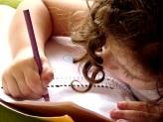  Literacy  In literacy we will continue to practise our handwriting and make sure that we get the size and shape of the letters correct. We will practise writing sentences with a focus on using capital letters and full stops accurately. We will look at the story – Goldilocks and the Three Bears in talk for writing sessions. | 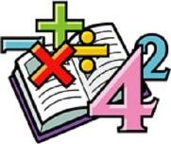  Maths  In maths we will be focusing on addition and subtraction. We will be looking at parts and wholes, where we will introduce whole part models. We will also look at number bonds to ten then use those facts to add and subtract numbers, where we can look at adding and subtracting 1 and 2. | 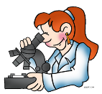  Science  We will work as scientists to learn about the seasons. We will start by looking at the weather in Autumn and how that changes in Winter. To aid our learning about Autumn, we will be going on a class walk to identify key signs in our local area. We will also be learning how to record Autumn weather and different types of animals in Winter. | 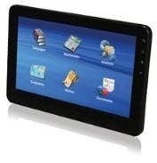  Computing  In Computing this half term, we will be looking at data. We will research different ways that we can represent data then use those ideas to collect and record data of our own. Towards the end of the half term, we will be designing an invention of our own that can gather data.
Humanities  In geography we will be looking at our local area and learning our address including our postcode. We will be looking at out journey to school, different types of homes and using aerial maps. | Year 1  Overdale Community Primary School  Autumn term 2 2023  Big Question: What are seasons and how do they change? |  | 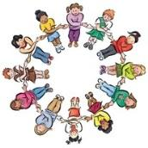  PSHE In PSHE we will be thinking about Health and wellbeing. We will explore our emotions, how we keep safe and well and who helps us to keep safe and well. We will also discuss the importance of relaxation and suitable bedtime routines.
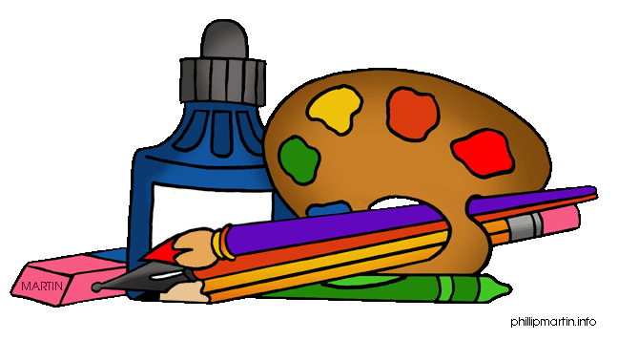  Art and DT  In DT we will be looking at structures and designing , making and evaluating our own windmill | 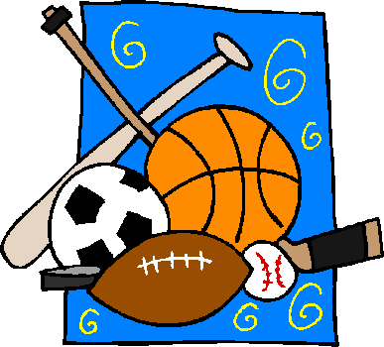  PE  In PE, our focus this half tern will be on Gymnastics. We will be using most of the half term to look at balance and how we can use this to learn key fundamental skills. | 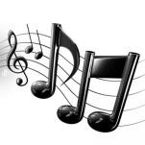  Music In music we will be looking at pulse and rhythm. We will start by using our hands and voice to explore these elements, where we will build up to play a simple rhythm on an instrument. | RE In RE, we will look at how Christians think of God and what beliefs they have about God. We will also look at different pieces of art and music that expresses ideas about God and use that to explore our own ideas of God.
Reading: Children will be expected to read their home reading books three times a week with a written comment from a parent in their reading record. Children will also have access to their class Lending Library where they can bring home alternative books to read for pleasure with an adult
Maths: We will be focusing on addition and subtraction – any help at home with this would be great – thank you
Spelling: We will be looking at Phase 5 words. A sheet will come home each week for you to practise these words at home.

